UNIVERSITI TUNKU ABDUL RAHMAN

ACADEMIC YEAR 2020/2021

JANUARY 2021 TRIMESTER

FINAL ASSESSMENT

**ANSWER SCRIPT**

**Candidate is required to fill in ALL the information below:**

|  |  |  |  |
| --- | --- | --- | --- |
| Name : (as stated in Student Identity Card) | TAN YING YAO 1703648 | | |
| Faculty /Institute/ Centre: | LKC FES | Programme : | SE |
| Index No.  (in numbers) : | U00584EBSEF | Index No.  (in words) : | U-ZERO-ZERO-FIVE-EIGHT-FOUR-EBSEF |
| Course Code : | UECS3383 | Course Description : | SOFTWARE QUALITY ASSURANCE |
| Submission Date : | 06/05/21 | Time : | 0830AM |

|  |  |  |
| --- | --- | --- |
| **QUESTION NUMBER** | **FOR EXAMINER’S USE ONLY** | |
| **MARKS** | |
| **Internal** | **External** |
|  |  |  |
|  |  |  |
|  |  |  |
|  |  |  |
|  |  |  |
|  |  |  |
|  |  |  |
|  |  |  |
|  |  |  |
|  |  |  |
| **TOTAL MARKS** |  |  |



**DECLARATION STATEMENT**

I, **TAN YING YAO** (Name), Student ID No. **1703648** hereby solemnly and sincerely declare and confirm that I have read, understood and shall abide and comply with all laws, rules, regulations, guidelines and lawful instruction of the University and its staff in relation to the commencement of any assessment / examination during my programme of study in Universiti Tunku Abdul Rahman.

I hereby declare that my submission for all assessment / examination during my programme of study in the University shall be based on my original work, not plagiarised from any source(s) except for citations and quotations which have been duly acknowledged. I am fully aware that students who are suspected of violating this pledge are liable to be referred to the Examination Disciplinary Committee of the University.

TANYINGYAO

Name: TAN YING YAO

Student’s I.C. / Passport No.: 971210-14-5673

Date: 06/05/21

Index Number (in figure): U00584EBSEF Course Code: UECS3383 Page: 1

Q1. (a) Draw Business Model

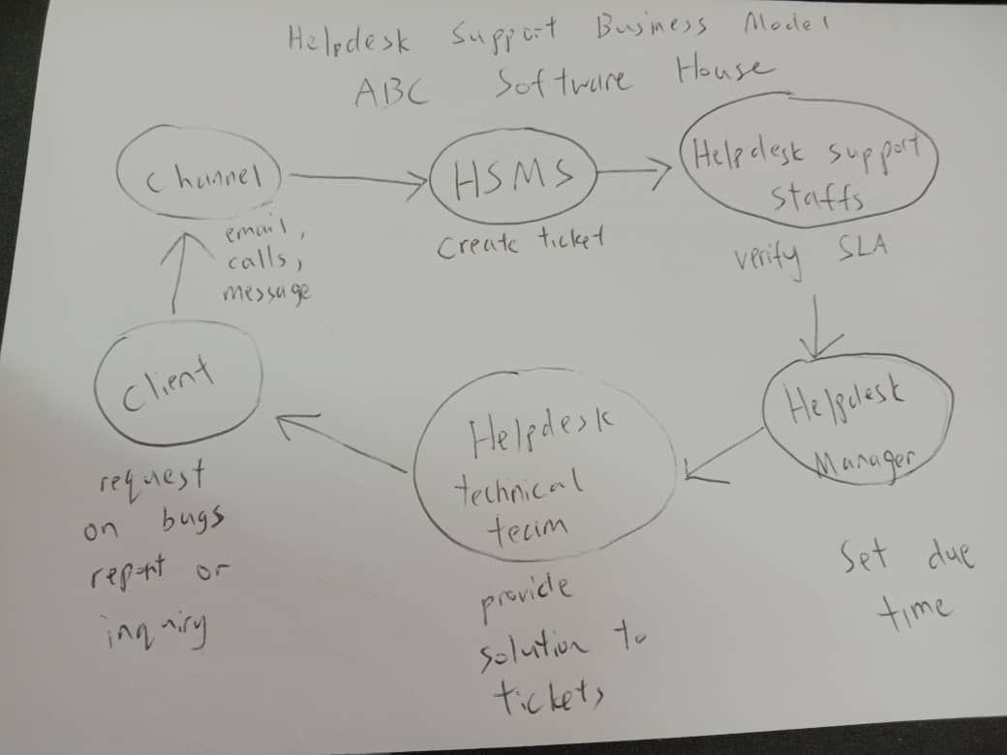

(b)

(i) Helpdesk Support Service South-East Asia (Draft)

Index Number (in figure): U00584EBSEF Course Code: UECS3383 Page: 2

(ii)

|  |  |  |
| --- | --- | --- |
| Company Name: ABC Software House | Form No. 001 | |
| Form Title: Helpdesk Support Service South-East Asia | Rev No. 001 | |
| Date(DD/MM/YYYY): Date of Issue | | Effective Date (DD/MM/YYYY to DD/MM/YYYY): Start Date to End Date |
| SECTION A: General Information of Third Party Service Provider | | |
| Company Name:  Name of the company | | Contact (Name, Email, etc):  Contact information of company |
| Company Location:  Address of the company | | |
| SECTION B: General Information of Organization of Customer | | |
| Company Name:  Name of the organization of customer | | Contact (Name, Email, etc):  Contact information of organization of customer |
| Company Location:  Address of the organization of customer | | |
| Service Provided | | |
| 1. The third-party service provider is required to monitor, track and control information regarding end-user  2. The helpdesk management system is required to perform all incident management, problem management and change management.  3. The third-party service provider is required to achieve the following SMART metrics:  i.  ii.  iii.  …  4. The third party service provider is required to achieve the following SMART criteria (i.e. Smart, Measurable, Attainable, Reliable and Timely):  i.  ii.  iii.  … | | |
| SECTION C: Approval by both Parties | | |
| Approval by Company:  ________________________________  (Date: DD/MM/YYYY) | | Approval by Organization of Customer:  ________________________________  (Date: DD/MM/YYYY) |

(iii)

|  |  |  |  |  |  |
| --- | --- | --- | --- | --- | --- |
| ID | Date | Description | Expected Result | Actual Result | Company |
| ABC101 | 05/07/2021 | At least 5 out of 10 customer satisfaction rating | 95% | 90% | SEA Company |
| ABC102 | 06/07/2021 | Ticket is resolved within 1 hour and 30 minutes | 95% | 96% | SEA Company |
| ABC103 | 13/09/2021 | Ticket is replied within 10 minutes | 95% | 97% | SEA Company |

Index Number (in figure): U00584EBSEF Course Code: UECS3383 Page: 4

2) a)

(i) I propose the usage of the IT Infrastructure Library (ITIL) to the CEO. ITIL can help cut IT costs, ensure customer satisfaction and improve productivity.

(ii) ITIL is the best SPI for providing a truckload of benefits to service providers such as help desk. ITIL’s core advantage is that it ensures that services are delivered efficiently and effectively. It has a core tenant of concepts and rules which can serve as a guideline for services. ITIL provides detailed procedure, tasks and metrics to help ensure the help desk runs smoothly. ITIL also has a tried and tested guideline which can help resolve service failure and operate routine tasks. ITIL can also help reduce service disruption and result in a better handling of business risks.

(iii)

Firstly, the potential challenge will be the repetitive and time-consuming tasks being performed for frequently used IT services and commonly asked questions. The staffs are forced into repetitive tasks and answering the same question over and over again.

Secondly, help desk also face the challenge of repeating issues that keep popping up. Recurring problems can cost a lot of IT help desk resource. Users often report the same problem resulting in a waste of enormous amount of time and resources to resolve the same problem. This is due to a lack of ITIL knowledge which result in the surge of this issue.

Thirdly, help desks can get overwhelmed by too many phone requests. The IT help desk team is constantly interrupted by new requests and calls which result in a drop in productivity. The user satisfaction decreases due to the long queue required and their issue will take a longer time to be resolved.

Index Number (in figure): U00584EBSEF Course Code: UECS3383 Page: 5

(iv)

Firstly, regarding help desk’s tendency to result in repetitive and time-consuming task, it can be solved by adding a frequently used IT services and FAQ to the web portals. This can help save time and resources by referring the users to frequently asked questions instead of taking up the time of the staffs. This can result in an automation of the request resolution process. For example, adding a function that allows for users to personally reset their password and create new email account can help reduce the need for a staff to guide them.

Secondly, problem management can solve the problem of repeating issues. By analysing and identifying these common incidents, creating a record of the problem can help fix the issue at hand. This will result in less repeating of work and increase user satisfaction.

Thirdly, A self-service portal where users can raise their questions and inquiry online can help reduce the number of phone calls and interruption. This frees up the help desk team to focus on resolving critical issues as the self-service portal can help share the burden of the request.

ITIL can help cut IT costs, ensure customer satisfaction and improve productivity of the help desk management system.

b)

(i) Periodical audit can help solve the challenges of time-consuming tasks, repeating issues and manage the number of phone calls. The periodical audit improves productivity as well as the efficiency and effectiveness of the operation. The periodical audit is held in between the projects halfway point, which result in a better management of the company goal and work.

(ii)

The audit should review and evaluate the overall process utilised by the help desk. This can help focus on problems handling and to prioritise any major problem to ensure a complete resolution can be achieved. The audit should also serve as an observation of the operation. The observation must include promptness of answering problems and sufficient knowledge to solve the issues quickly. The audit should also perform tests to ensure all of the system’s question are properly documented. The internal audit should also evaluate whether the management has issue transparent work and responsibility for the help desk. The internal audit should also evaluate and test the training of the technicians. This can result in a higher awareness of the technician regarding the hardware and software.

Index Number (in figure): U00584EBSEF Course Code: UECS3383 Page: 6

3)

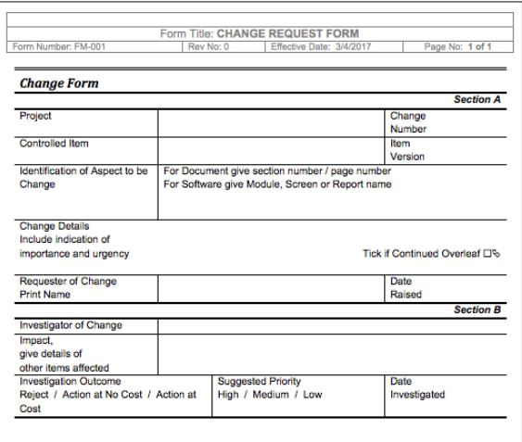

|  |  |  |
| --- | --- | --- |
|  | Q3 (a) | Q3 (b) Justification and Consequences |
| 1 | Controlled Item should be revised into Incident Tracking Number | Controlled Item is too vague and unclear at a glimpse of the form. Incident Tracking Number serve as an important part of change request form as it allows the form to be properly document and searched in the future. A change form without the incident tracking number will result in disastrous consequences such as the failure to request changes and will result in project failure. The lack of a tracking number will also cause the inability to find and track the change made which is detrimental to the project. This will indirectly cause the loss of resources and time. |
| 2 | Impact Details should be listed in more detail | The impact details must include the impact level to ensure that the change won’t impact other factors in the project. The lack of impact detail will be disastrous towards the project as there is no documentation of what will be changed and modified. The smallest modification may result in project failure or delivery due to the lack of documentation. The impact detail should list in detail of all the changes and modification made to make sure everyone in the SQA team is aware of the change to ensure the project is delivered on a timely and efficient schedule. The lack of impact detail will cost a waste in resources and time. |
| 3 | Change Details should include change reason | An explanation for why the change has been requested must be included in the details. The reason for change must be discussed between the stakeholders in order to document their words. The need for a change reason is monumental due to the fact that the justification needed to suggest such change. The lack of a change reason will invalidate the change form due to the lack of justification to perform said change. This can result in the change forms being rejected and delay the project completion. The lack of a detailed change reason also causes the project to lose its focus and scope. This in turn result in a waste of resources and time. |
| 4 | Investigation Outcome can be elaborated by adding proposed action | The steps needed to address the change must be written down and documented to ensure that everyone is aware of the changes. The list of proposed action should be written down to provide a solution to the investigation. The lack of a proposed action will result in project failure and even a delay of project delivery. The inclusion of a proposed action can ensure that the project is on time and follows the schedule properly. The failure to do so will result in resources and time being wasted. |
| 5 | Identification of Aspect to be Change should be revised more clearly | The complete changes made must be documented and written down clearly. The changes made must be correctly identified to ensure that the project does not deviate from its requirements. The lack of proper documentation will result in project failure for the SQA team. The lack of knowledge regarding which aspect to be change will also result in project delay. This will cost more resources and time to be wasted. |